Data Science Job Salaries
Author: Shivalika Singh
Domain: Finance Analyst
Project Difficulty Level: Intermediate
Tools Used: Microsoft Excel, MySQL, Power BI

1 Introduction
The rapid expansion of data-driven decision-making has significantly increased demand for data science professionals. Salaries in this field vary widely across job roles, experience levels, employment types, and geographic locations.
This project analyzes a comprehensive dataset of global salaries in the data science industry, focusing on identifying high-paying job roles, salary growth across experience levels, and the most rewarding countries for employment.
Data Columns:
○ work_year: Year of the job role.
○ experience_level: Entry-level, mid-level, senior, etc.
○ employment_type: Full-time, contract, etc.
○ job_title: Role title (e.g., Data Scientist, Analyst).
○ salary: Reported salary.
○ salary_currency: Currency of salary.
○ salary_in_usd: Converted salary in USD.
○ employee_residence: Country

2 Project Objectives
✔ Clean and transform the raw dataset into structured form
✔ Analyze salaries by:
- Experience level (EN, MI, SE, EX)
- Employment type (FT, PT, CT, FL)
- Job position/role
✔ Identify Top 5 highest-paid job roles
✔ Compare salary trends geographically
✔ Provide recommendations for suitable job role & location
✔ Create dynamic dashboards for interpretation through Power BI

3 Dataset & Tools Overview
Component | Description
Dataset | Global salaries from data science roles
Data Cleaning | Removal of duplicates, fixing missing fields, standardizing formats
Analysis Tools | Excel & MySQL
Visualization | Power BI reports and dashboards
Functions Used | AVERAGEIF, AVERAGEIFS, VLOOKUP, sorting/filtering, pivot tables




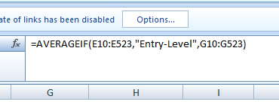

4 Data Cleaning & Challenges
During the initial stage, the dataset contained:
- Inconsistent employment type abbreviations
- Mixed currency formats
- Null/blank entries in job title or salary
- Country codes not easily readable (e.g., “IN”, “US”, “JP”)

How issues were solved:
- Unified employment types using Find & Replace
- Used Excel formula transformations to standardize salary fields
- Removed duplicates using Data → Remove Duplicates
- Added a separate lookup sheet for country name mapping
- Ensured raw data was kept in a separate sheet for integrity and references
- This process ensured reliable and professional analysis.



5 Methodology of Analysis

✔ Excel Analysis
- Used AVERAGEIF / AVERAGEIFS to compute:
  - Average salary by job type
  - Average salary by employment type
  - Salary variations across experience level

✔ SQL Operations
- Imported dataset into MySQL Workbench
- Queried using GROUP BY, ORDER BY, and aggregate functions
- Identified top salary segments efficiently

✔ Power BI Visualization
- Developed dashboards for country-level mapping
- Bar charts for job roles & experience levels
- Filters for user-driven insights

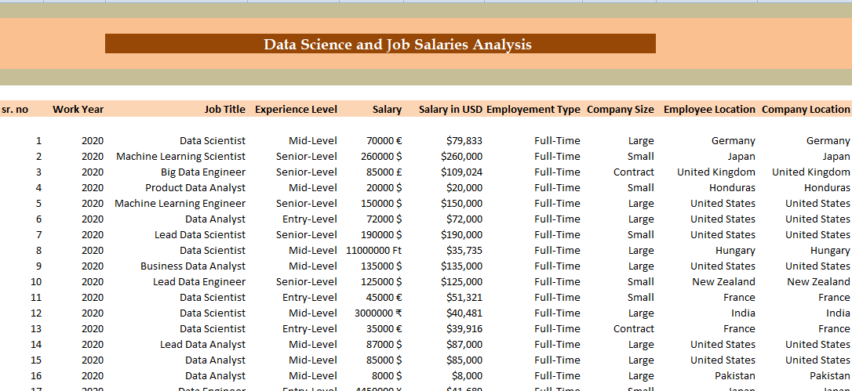

6 Key Insights
📌 Experience Pays Significantly
Salary increases strongly from EN → MI → SE → EX level
Executives (EX) earn the highest across all job types
📌 Full-Time Employees Earn More
FT > CT > FL > PT in average salary structure

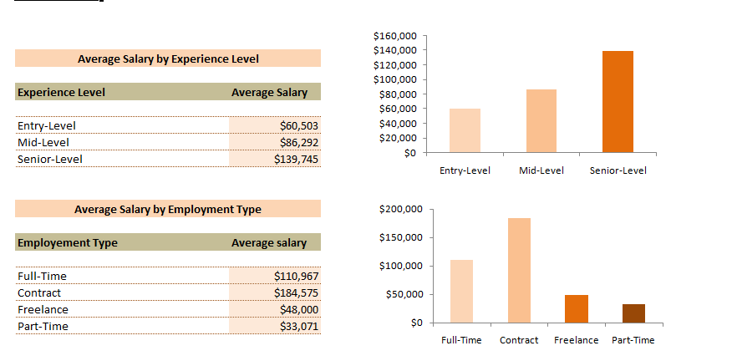

📌 Job Roles: Top 5 Highest-Paid Positions
- Data Science Manager
- Machine Learning Engineer
- Data Architect
- Principal Data Scientist
- AI Research Engineer
📌 Countries Offering Highest Salaries
- United States (Leading globally)
- Switzerland
- Australia
- United Kingdom
- Canada
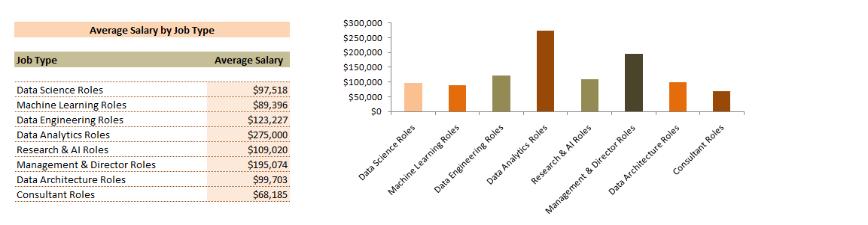

Finance-based data science roles are among the top-rewarded categories

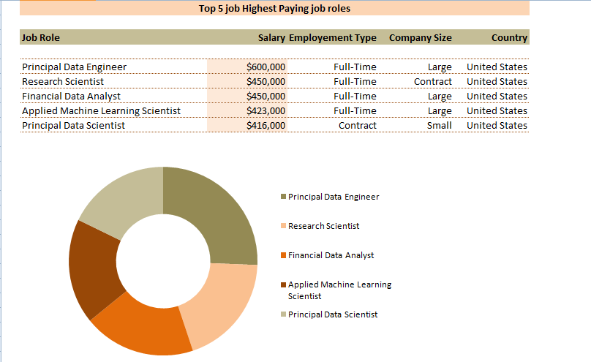

7 Conclusion
This study concludes that:
✔ Salary is highly dependent on experience and job specialization
✔ Advanced & leadership roles offer exponentially higher pay
✔ The US market remains the most lucrative global opportunity
✔ Full-time employment provides strongest salary reliability

8 Career Recommendation (Personal Outlook)
Based on the analysis:
- I would choose Machine Learning Engineer or Data Science Manager
- Ideal location for career growth: United States
- Industry alignment: Finance Analytics, AI-driven decision support systems

9 Skills & Learning Outcomes
Throughout the project, I gained:
✔ Practical experience in Excel formulas, Pivot tables, and dashboarding
✔ Improved SQL query writing skills
✔ Stronger understanding of data cleaning workflows
✔ Business-focused interpretation of salary analytics
✔ Confidence in using Power BI for professional visualization

10 Final Remarks
This project strengthened my analytical and technical competence as a future Financial Data Analyst. It not only improved my tool-based capabilities but also guided my career direction in data science.

Reference link to project:
https://github.com/shivalikasingh19/Data-Science-job-Salaries

